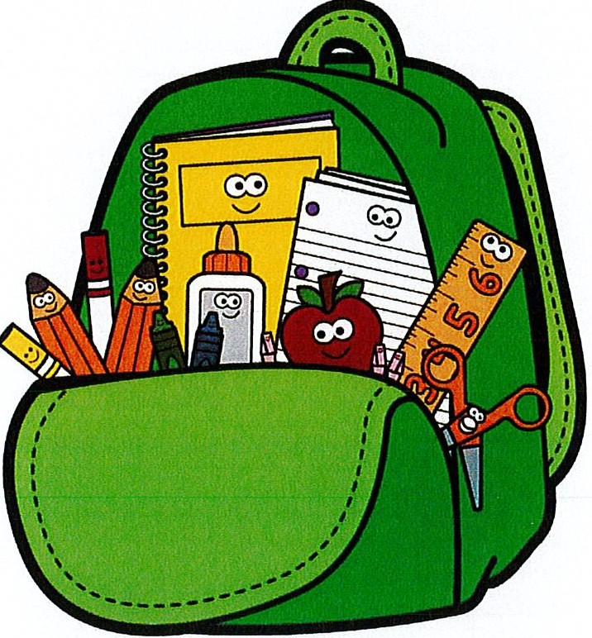
PK Supply List 2023-2024

- 1 regular-sized backpack

- A change of clothes, including underwear and shoes (will be kept in student cubby)

- 1 box of tissues

- 1 pack of non-antibacterial wet wipes for hygiene purposes

- Toothbrush and toothpaste (will be kept in child's cubby)

- Optional: small blanket or pillow for rest time

Scio Central School

Supply List 2023-2024

*1 backpack (large enough to put folders in)
*1 supply box
*1 set of headphones
*2 packages of 24 count crayons
*1 package washable markers
*1 (4 count) package dry erase markers
*20 glue sticks
*2 containers disinfectant wipes
*1 box of tissues
*1 package quart sized Ziplock baggies
*1 set of headphones

Headphones are for computer use only at school. They must be over the ear style. No ear buds! Please label with your child's name. See picture for an example.
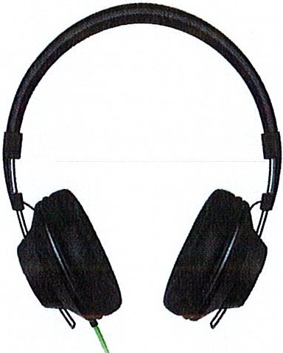

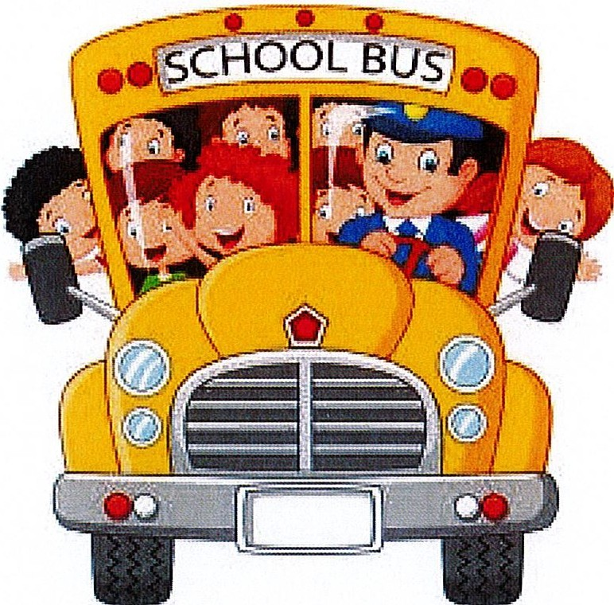
Scio's First Grade School Supply List 2023-2024

- baCKpaCK
- headphones (please, no earbuds)
- 1 (1 in.) 3 -ring binder, with Clear front and bac,
- 1 plastic pocKet folder
- 'Plastic pencil/SUPPIY box
- 25 sharpened penciIs
- 1 hand-held eraser (please no pencil top erasers)
- Scissors
- 6 g1ue StiCl S
- Crayons (box of 2l/-)
- q. pacKets of post-it notes
- q. thin dry erase marKers
- 3 boxes of tissues
- 1 empty shoebox

Second Grade School Supply List 2023-2024 School Year

- 1 hard pencil case
- 1 pack of dry erase markers
- 1 pack of pencils
- 2 pocket folders
- 1 pair of headphones (no earbuds please)
- 1 box of crayons
- 1 pack of colored pencils
- 2 highlighters
- 1 primary composition book
- 1 block eraser
- 1 container of disinfectant wipes

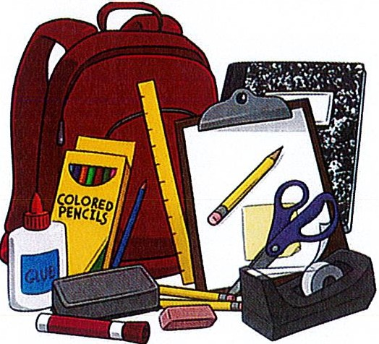
And most importantly .... A positive attitude ready to tackle the school year!

See you soon,
Mrs. Burdick and Ms. Washburn

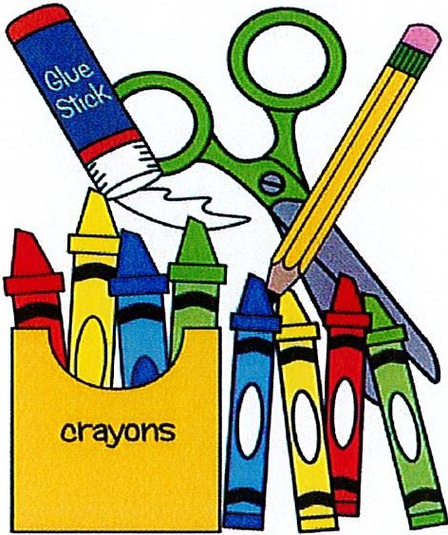
Third Grade Supply List Mrs. Root and Miss Harvey

Please be sure to bring the following on the first day of schooll

- Ten Glue Sticks
- Two: marble, bound, composition notebooks
- 40 #2 pencils (non-mechanical) NO PENS
- One box of colored pencils
- One box of crayons
- One box of tissues
- One pencil storage box
- One package of eraser caps
- One: 1 inch three ring binder
- Four expo dry erase markers
- One water bottle with lid that closes.
- One pair of scissors
- One pair of headphones

Thank you for coming to school preparedI

Scio Central School Fourth Grade Supply List

- 40+ pencils
- 2 highlighters
- 4 Expo Markers
- Erasers (NOT cap type that goes on top of pencil)
- 2 Composition books
- 1 package loose leaf paper
- 8 Glue sticks
- 2 Boxes Kleenex
- 1 pair scissors
- Water bottle
- Colored pencils
- 1 old sock for eraser
- 1 pair of ear buds or headphones

Fifth and Sixth Grade
Supply list
2023-2024
***Please label ALL items with a permanent marker.***

Please be sure to bring the following items on the first day of school: Social Studies:
- One marble bound composition notebook (NOT SPIRAL)
- One black ULTRA FINE point permanent marker (Sharpie)
- Two different colored highlighters

Reading and Writing:
- One marble bound composition notebook (NOT SPIRAL)
- One black ULTRA FINE point permanent marker (Sharpie)
- Two different colored highlighters

Math:
- One SPIRAL notebook

Science:
- One marble bound composition notebook (NOT SPIRAL)
- One laminated (shiny) or plastic folder with pockets, three-hole punched

Homeroom:
- Earbuds or headphones
- Two boxes of #2 pencils (for all classes)

NO MECHANICAL PENCILS! NO PENS!
- Two large boxes of tissues
- One three-ring binder (3-INCH)
- Dividers for the binder
- One handheld pencil sharpener
- Two different colored highlighters
- Colored pencils, 12 pack
- Soft pencil case (three-hole punched to put in binder)
- One packet of Post-it Notes

Thank you for coming to school prepared!

